Assessment 8
Ayesha Siddiqa S
192324305
CSA1511
CLOUD COMPUTING AND BIG DATA ANALYTICS
Case Study 1: Smart Retail Inventory Management System
Architecture Components
Component | Application in this system
Clients | POS systems, store dashboards, barcode scanners, and store devices
Internet / Network | Connects stores to the cloud
VPN | Provides a secure connection between stores and cloud services
Firewall | Blocks unauthorized network traffic
API Gateway | Receives and routes API requests from store devices
Application Services | Inventory, order, user, and authentication services
Compute Services | Cloud VMs or containers run the application
Cloud Storage | Stores product data, transaction logs, and analytics datasets
Analytics Service | Analyzes sales and inventory information
Demand Forecasting | Predicts future product demand
Monitoring | Tracks system performance, errors, and availability

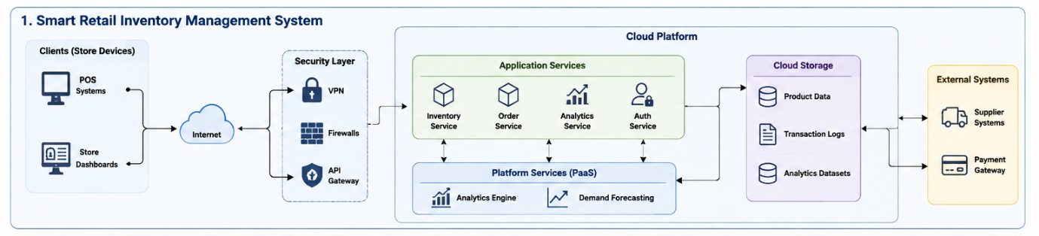
Data Flow
POS / Store Devices → Internet → VPN & Firewall → API Gateway → Cloud Application Services → Database / Cloud Storage
Analytics services process the stored data and provide information for sales analysis and demand forecasting.
Main Benefits
- Real-time inventory tracking
- Reduced stock shortages
- Better demand prediction
- Centralized data management
- Secure communication between stores and cloud
- Scalable cloud infrastructure
Main Challenges
- Protecting sensitive transaction data
- Maintaining connectivity between stores and cloud
- Handling large numbers of transactions
- Keeping inventory information synchronized
- Managing cloud storage and computing costs

Case Study 2: Cloud-Based Document Collaboration System
Architecture Components
Component | Application in this system
Clients | Web browsers, desktop applications, and mobile devices
Internet | Connects users from different locations
CDN | Delivers content efficiently to users globally
Load Balancer | Distributes requests between servers
API Gateway | Handles API requests from different clients
Identity Management | Manages user authentication and identities
Access Permissions | Controls who can view or edit documents
Document Service | Creates, reads, and manages documents
Collaboration Service | Enables multiple users to work together
Version Control | Maintains previous versions of documents
Real-Time Sync | Synchronizes changes between users
Cloud Storage | Stores documents, metadata, and version history
Encryption | Protects documents during storage and transmission

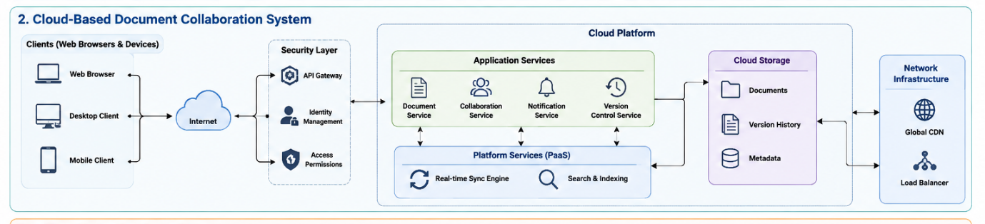

Data Flow
Browser / Mobile / Desktop → Internet → CDN / Load Balancer → API Gateway → Collaboration Services → Distributed Cloud Storage
When a user edits a document, the real-time synchronization service sends the changes to other connected users.
Main Benefits
- Real-time collaboration
- Access from anywhere
- Automatic document storage
- Version history
- Multiple users can edit simultaneously
- High availability using distributed cloud infrastructure
Main Challenges
- Maintaining real-time synchronization
- Preventing conflicting edits
- Protecting confidential documents
- Managing large amounts of storage
- Providing low latency to users worldwide
- Managing user permissions

Case Study 3: Online Food Ordering Platform
Architecture Components
Component | Application in this system
Clients | Mobile applications and web browsers
Internet | Connects customers to the platform
HTTPS/SSL | Encrypts communication
Authentication Tokens | Verifies logged-in users
Role-Based Access Control | Provides different permissions to customers, restaurants, and administrators
Load Balancer | Distributes incoming requests
API Gateway | Routes REST API requests
User Service | Manages customer accounts
Menu Service | Manages restaurant menus
Order Service | Processes food orders
Payment Service | Handles payments
Notification Service | Sends order updates
Kubernetes | Runs and scales containers
Virtual Machines | Provide underlying computing infrastructure
Cloud Storage | Stores menu images, invoices, and other files
Database | Stores customer, restaurant, order, and transaction data

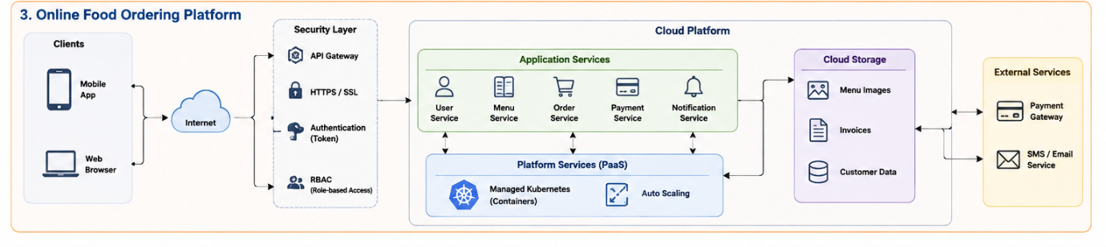
Data Flow
Mobile App / Web Browser → Internet → Load Balancer → API Gateway → Kubernetes / Backend Services → Database & Cloud Storage
For example, when a customer places an order:
Customer → Menu Service → Order Service → Payment Service → Restaurant → Notification Service
The customer then receives an order confirmation and status updates.
Main Benefits
- Online ordering from web and mobile
- Scalable infrastructure
- Fast order processing
- Secure payments
- Real-time notifications
- High availability using Kubernetes
- Easy scaling during peak hours
Main Challenges
- Handling high traffic during lunch and dinner
- Protecting customer and payment information
- Maintaining database consistency
- Managing payment failures
- Scaling services automatically

